Ex.No. 11: Implementation of IoT-based Smart Agriculture using MATLAB Date
Objective 1:
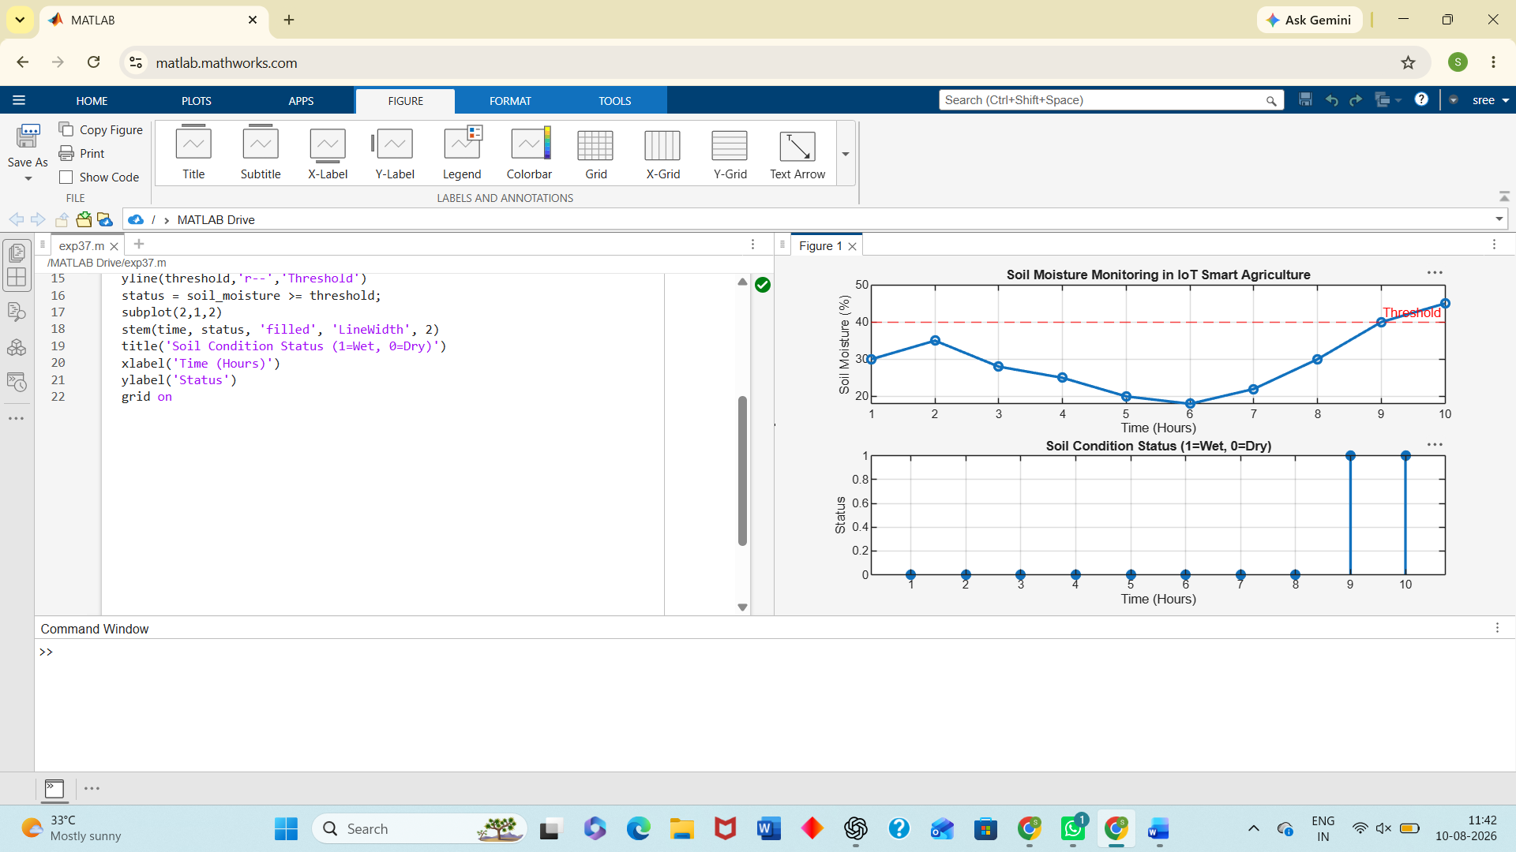
Objective 2:
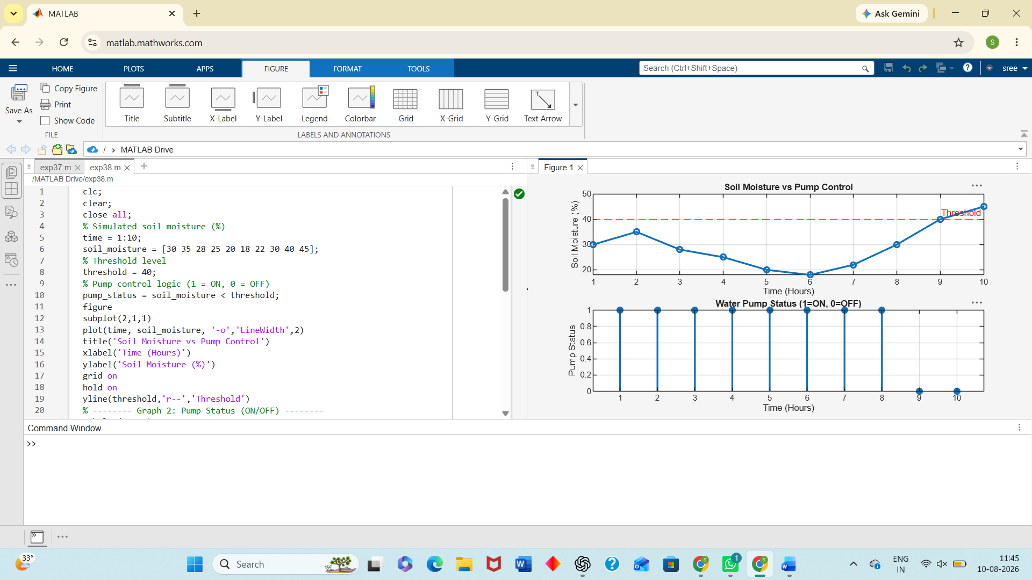
Objective 3:
